**Spring REST using Spring Boot 3**

**Exercise 1:Create a Spring Web Project using Maven**

Steps to Create Spring Boot Project:

1. Install Prerequisites
2. Create Project
3. Add Log in Main Class

|  |
| --- |
| SpringLearnApplication.java  package com.cognizant.springlearn;  import org.springframework.boot.SpringApplication;  import org.springframework.boot.autoconfigure.SpringBootApplication;  @SpringBootApplication  public class SpringLearnApplication {  public static void main(String[] args) {  System.out.println("Application Started in VS Code");  SpringApplication.run(SpringLearnApplication.class, args);  }  } |

**Output:**

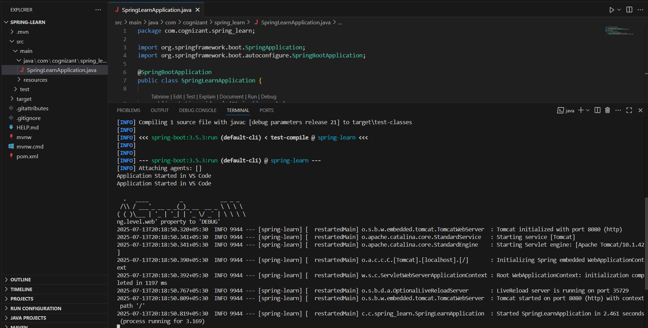

**Exercise 2:Spring Core – Load Country from Spring Configuration XML**

**1.**Create spring configuration file date-format.xml

|  |
| --- |
| date-format.xml  <?xml version="1.0" encoding="UTF-8"?>  <beans xmlns="http://www.springframework.org/schema/beans"         xmlns:xsi="http://www.w3.org/2001/XMLSchema-instance"         xsi:schemaLocation="http://www.springframework.org/schema/beans                             https://www.springframework.org/schema/beans/spring-beans.xsd">      <bean id="dateFormat" class="java.text.SimpleDateFormat">          <constructor-arg value="dd/MM/yyyy" />      </bean>  </beans> |

**2.** Update SpringLearnApplication.java

|  |
| --- |
| package com.cognizant.spring_learn;  import java.text.SimpleDateFormat;  import java.util.Date;  import org.springframework.boot.SpringApplication;  import org.springframework.boot.autoconfigure.SpringBootApplication;  import org.springframework.context.ApplicationContext;  import org.springframework.context.support.ClassPathXmlApplicationContext;  @SpringBootApplication  public class SpringLearnApplication {      public static void main(String[] args) throws Exception {          System.out.println("Application Started in VS Code");          SpringApplication.run(SpringLearnApplication.class, args);          displayDate();      }  public static void displayDate() throws Exception {          ApplicationContext context = new ClassPathXmlApplicationContext("date-format.xml");          SimpleDateFormat format = context.getBean("dateFormat", SimpleDateFormat.class);          Date parsedDate = format.parse("31/12/2018");          System.out.println("Parsed Date: " + parsedDate);      }} |

**Output:**

